## **Current Status**

A dataset containing reviews of Amazon products given by the consumers has been selected for the recommendation system. The CSV file contains review text, ratings, product information, reviewer information, and other things.

Amazon uses a cloud computing platform called Amazon Web Services (AWS). It includes platform as a service (PaaS), infrastructure as a service (IaaS), packaged software as a service (SaaS) offerings. Its services can be separated into multiple categories like compute, Data management, networking, etc. according to the customer’s needs. Amazon has spread its data centers across availability zones in regions around the world. A region is a collection of AZs which contains multiple data centers. Amazon stores data as S3 objects in S3 buckets that give scalable object storage to backup data and helps to keep the data organized. For AWS users, PostgreSQL, Oracle, SQL Server, high-performance database “Amazon Aurora”, etc. are relational database management systems. Through Amazon DynamoDB, AWS offers NoSQL databases too. AWS provides administrators that can manage and keep track of cloud resource configurations, monitors resource and applications health. AWS also provides cloud security services and tools that help to measure potential security risks. AWS uses a variety of AI models for voice and text technology, text-to-speech translation, and image and facial analysis, etc. AWS also provides migration, hybrid cloud, networking, developer tools (Gillis, 2021).

## **Requirements**

The dataset was collected to make a recommendation system for the consumers by analyzing their previous reviews and ratings of the Amazone products. This system will recommend products to the consumers that they might like. The recommended products vary with every consumer because all consumers don’t have the same taste.

To build the system, first of all, the right datasets of the customer activities need to be collected. The amount of data will decide how good will be the recommendation system. The type of data that is being dealt with will decide the type of storage that needed to be implemented which might include a NoSQL or a SQL or some type of object storage. Then extraction of relevant information by filtering the data to make required and accurate recommendations is done using algorithms. There are different types of algorithms used for making a recommendation system which are shown below.

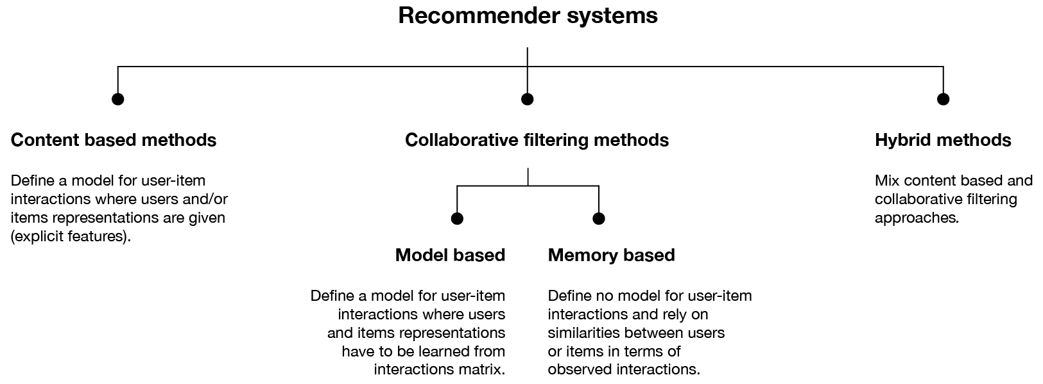

Figure 1: Algorithms used for making a recommendation system (Rocca, 2019).

Python will be the programming language used for making the system by using one of the above methods. Python provides its libraries that will help to make the system more easily. Matrix factorization will be also used while making the system (Sharma, 2018).